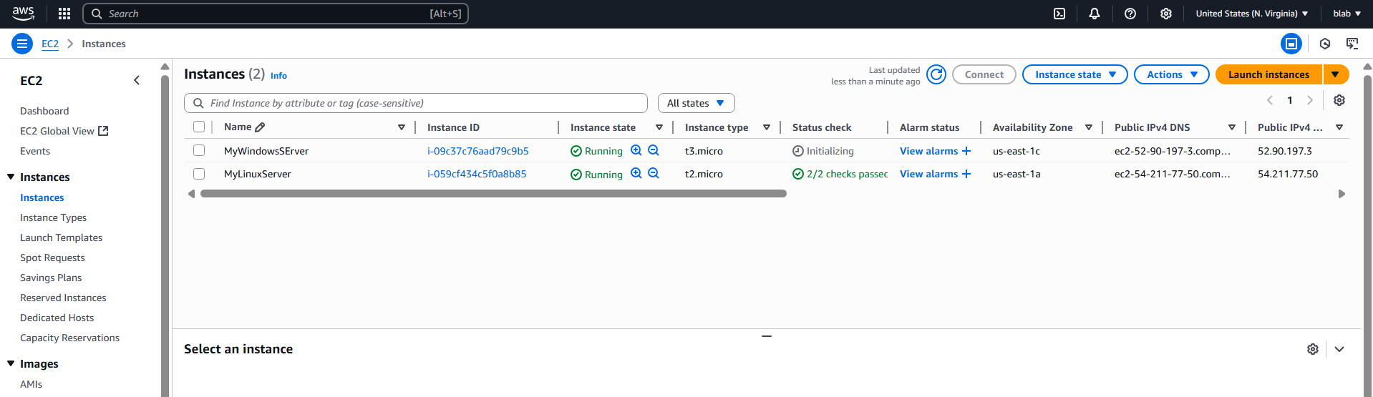

Creating 5GB Disk

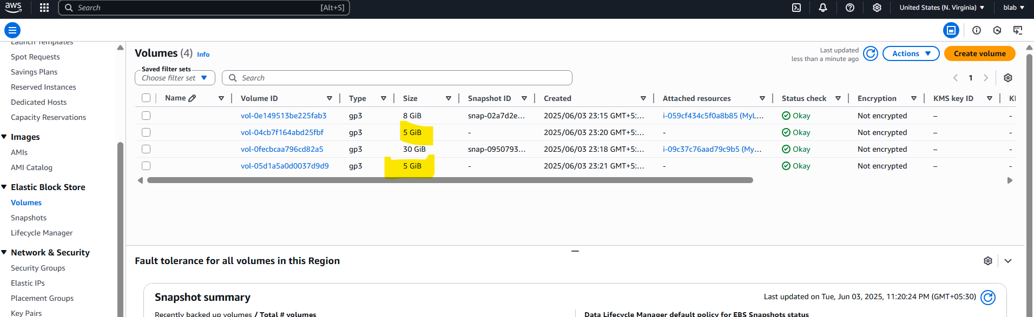

Attaching the volume to ec2 instance

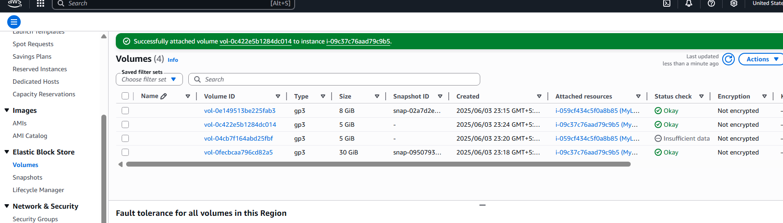

Creating Snapshot

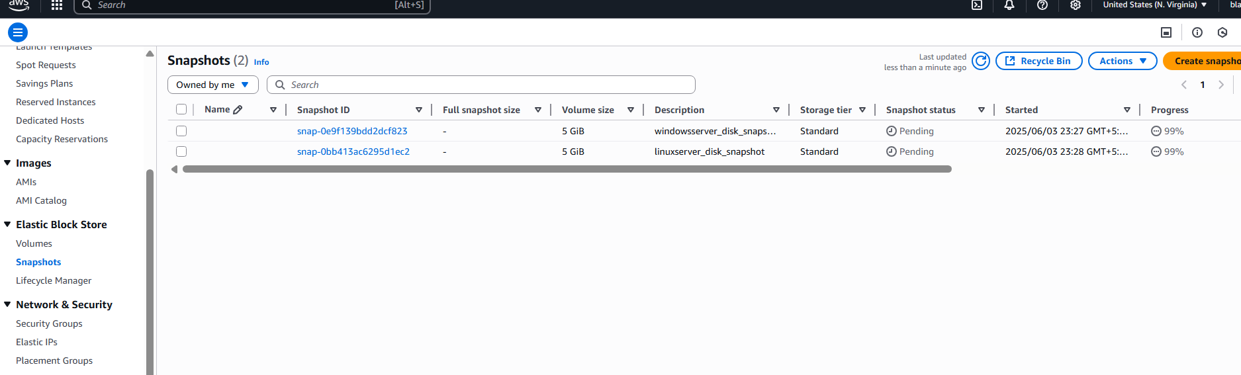

Creating volume from Snapshot

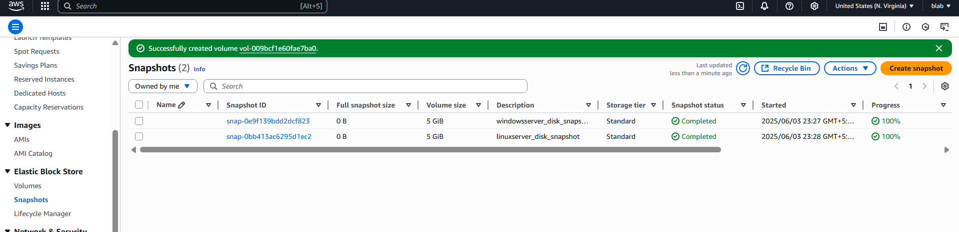

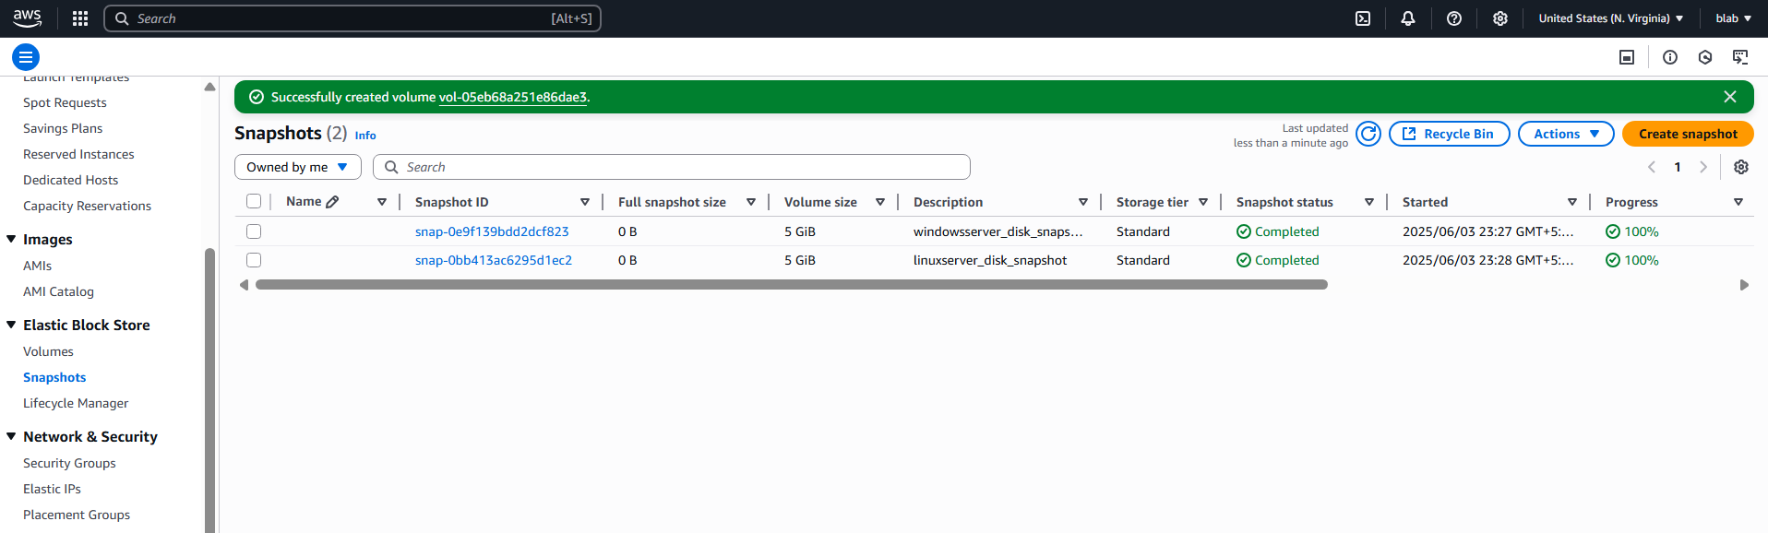

Attaching the newly created volume to ec2

